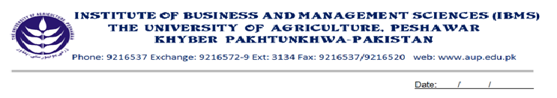
Program: BS (IT) -I
Course Name: Calculus & Analytical Geometry
Course Code: MT-301
Course Hours: 03
Total Weeks: 16
Total Hours: 48

Course Objectives

Calculus is a vast subject. It has many applications in Engineering Sciences as well as in computer Sciences. It enables the students to define slopes of curves, to calculate velocity and acceleration of moving bodies. That’s why; the above course is planned for BCS students. The course contents are such that, after the completion of this course, students will be able to differentiate and integrate algebraic as well as trigonometric functions, at the end of the course student will be able to apply the concepts while solving problems of computers.

Week-1
-Complex Numbers,

Week-2
-Complex Numbers in polar Form
-De -Movire’s Theorem,
-Applications of De-Moivre’s Theorem.

Week-3
-Functions and Graphs,

Week-4
-Limits of different Functions,
-Left hand Limits and Right Hand Limits

Week-5
-Continuity of different Functions,

Week-6
-Differentiation, Rules of Differentiation,
-Derivatives of Algebraic Functions

Week-7
-Derivatives of Trigonometric and inverse Trigonometric Function,

Week-8
-Chain Rule,
-Applications of Chain Rule,

Week-9
-Equation of Tangent
-Equation of Normal.

Week-10
-Maxima, Minima and point of Inflection
-

Week-11
-Taylor Series
-Maclaurin Series

Week-12
-Integration of Simple Functions,
-Rules of Integrations

Week-13
-Integration by substitution and Integration by parts

Week-14
-Integration by Partial Fractions

Week-15
-Definite Integrals
-Properties of definite Integrals

Week-16
-Applications of definite Integrals.

Total Marks: 100
Final Examination: 100

Recommended Book:

1. Calculus by Thomas/Finney 9th Editions
2. Advance Engineering Mathematics by Erwin Kreyszig 8th Edition
3. Calculus and Analytical Geometry by Dr. Zia-ul Haq

